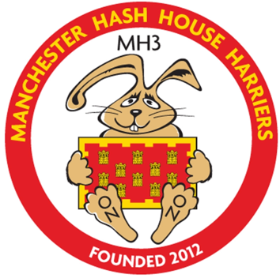
MANCHESTER H3 10TH ANNIVERSARY
01 - 03 JULY 2022

CASTLESHAW CENTRE, WATERWORKS ROAD,
DELPH, OLDHAM, OL3 5LZ

Hash Name
Real Name
Hash Kennel
E-Mail
Mobile Number
Presence | ☐ Friday |  |  | ☐ Saturday |  |  |  |  |  | ☐ Sunday
Accommodation | Price includes Fri & Sat night in bunkhouse 4-6 per room
Share with? | ☐ No preference
 | ☐ Yes, name:
I drink | ☐ Real ale |  |  | ☐ Red Wine
 | ☐ Lager |  |  | ☐ White Wine
 | ☐ Cider |  |  | ☐ Softies
I eat | ☐ Meat | ☐ Chicken |  | ☐ Fish |  |  |  | ☐ Vegetarian |  |  |  | ☐ Vegan
Allergies
Haberdashery | ☐ Male fit |  |  |  |  |  | ☐ Female fit
 | ☐ S |  | ☐ M |  | ☐ L |  |  |  | ☐ XL |  | ☐ XXL
Saturday trail | ☐ Long |  |  |  |  | ☐ Medium
Payment | £150 – due by 28 February 2022  Payment information will be sent on receipt of completed registration

